**Leslie Model Handout**

In this handout, we will take into account varying birth rates and survival rates for various age groups in order to model population. Human population models are based on the female population only, since they are the ones that reproduce. As an example, for simplicity, we can break women down into three age categories: 0-15, 15-30, and 30-45, assuming childbearing stops after 45. Assuming birth rates of 0.4271, 0.8498, and 0.1273, respectively for each class, and survival rates from the first class to the second class and from the second to the third are 0.9924 and 0.9826, respectively, then we have the following difference equations:



Note: 0.4271 + 0.8498 + 0.1273 sums to 1.4, so we are actually assuming that each woman has 2.8 babies (in particular, 1.4 female babies).

Supposing a female population of 30 million in each class, we can then use a spreadsheet to obtain:

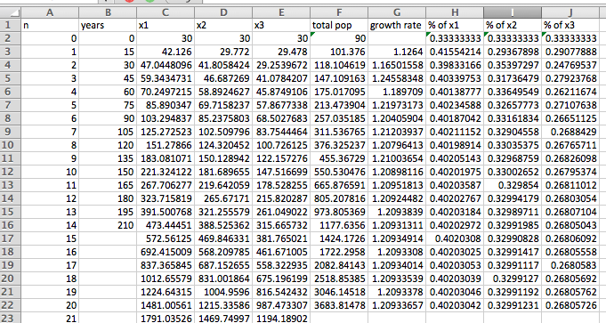

Notice: Since the population has been grouped into classes of 15 years, one time step corresponds to 15 years. We see that in the long run, the population grows at a rate of 20.9% every 15 years.

Another way to obtain this long term behavior is to view this problem as a matrix.

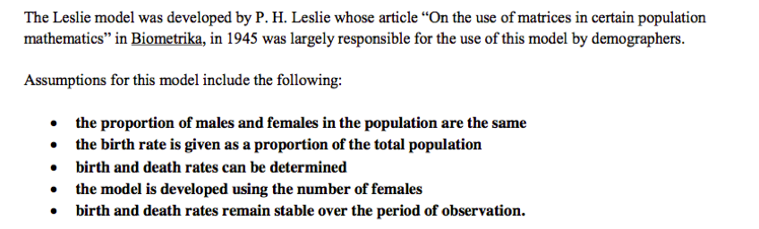

The Leslie matrix is given by:

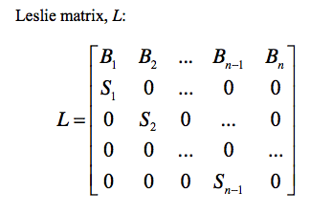

In our simplified example, we have:



To obtain the populations after 6 iterations (90 years), we would calculate , where  is the initial population distribution:



Notice that these are the same numbers we obtained from the previous spreadsheet calculations.

(Optional aside: for those that have taken/teach linear algebra, you will notice that we can also obtain the growth rate of 20.9% by calculating the largest eigenvalue.)

China Example

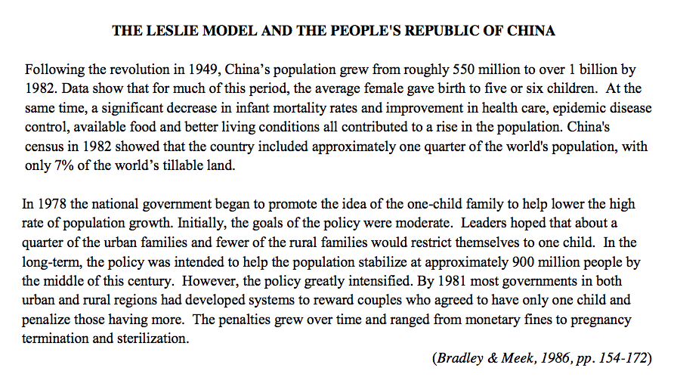

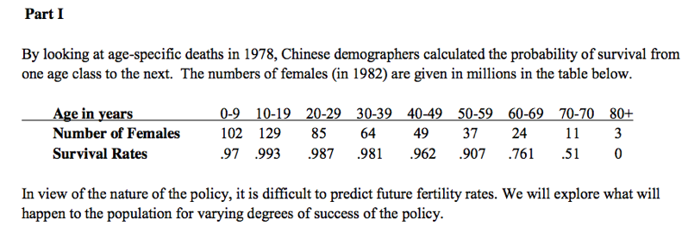

Let’s assume that China was able to institute a one child policy, and the birth rates for women 10-19 is 0.28 female children and for ages 20-29 is 0.22 female children.

a. Report the age distribution in the year 2082.

b. What is the long term population decay rate?

c. Do this in Excel and then using the Python linalg package.

China answers:

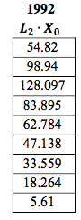

In 2082: 4.8, 6.1, 8.4, 11, 14, 19.5, 21.8, 22.6, 17.6

Long term decay rate of 25.4% every ten years